LAB 9

1- Write a program that continually takes a word from the user until he/she enters “stop”.


Example:
Inputs:
the
weather
is
perfect
stop

2- Write a program that continually prints 3th letters in given string.

Example:
string str = "Bugün hava çok güzel";
Output string: "Bühaoge"

3- Write a program that prints the number of characters of each word in the sentence.

Example:
string str = "Bugün hava çok güzel";
Output: 5 4 3 5

4- Write a program that prints true if the parentheses are invalid, otherwise false.

Example:

string str = "(a (b (c)) d)";
Output: true

string str = "(a (b (c (d (e) f) g) h) (i (j (k) l) m) n)";
Output: true

string str = "(a (b (c) d)";
Output: false

string str = "(a ))b ((c) d";
Output: false

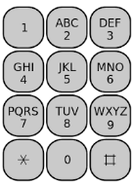
5- Write a program that takes a string from the user and constructs new strings which consist of sequence of digits for a phone keypad.

On the phone keypad, the alphabets are mapped to digits as follows: ABC(2), DEF(3), GHI(4), JKL(5), MNO(6), PQRS(7), TUV(8), WXYZ(9).

Example:
Input string: "DeRya"
Output strings: "33792"

6- Write a program that determines a text can be heard by Henry or not.

If Henry hears a word longer than five letters, he ignores it.

Example:
string str = "Henry, you just won the lottery!!!"
Output: Henry ignores it

string str = "Watch out for that red car, Henry"
Output: Henry hears it

string str = "Don’t eat pizza"
Output: Henry ignores it

7- Write a program that determines a text is Alliteratives or not.

Alliteration occurs when all the words start with the same letter.


Examples:
string str = "Alice’s aunt ate apples and acorns around August"
Output: true

string str = "Fred’s friends fried Fritos for Friday’s food"
Output: true

string str = "Hannah’s home has heat hopefully"
Output: true

string str = "Larry’s lizard likes leaping leopards"
Output: true

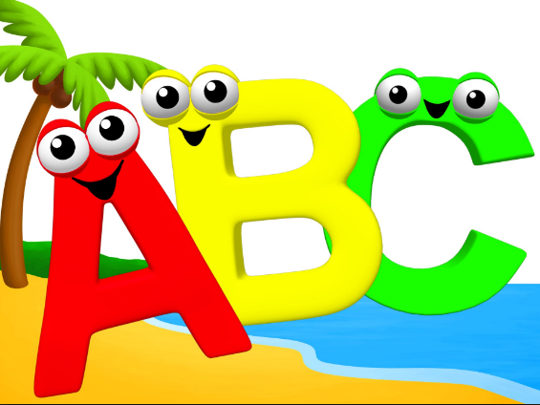
8- Write a program that finds all letters that are not present in a given string.

Example:
string str = "Bugün hava çok güzel. Deniz, kumsal ve güneş muhteşem olacak."

Output string: "f ğ ı j ö p r y"

9- Write a program that takes a character from the user and determines whether given character is the majority character in the string or not.

The majority character in the string, S, of size n is a character that appears more than n/2 times.

Example:
string str = "ece ve eve deeeeeeeeeermişim"

Input: e
Output: yes

Input: v
Output: no

10- Write a program that takes two strings from the user and checks whether they are anagram or not.

Two words are anagram if they contain the same letters in any order (if their character frequencies are the same).

Example:
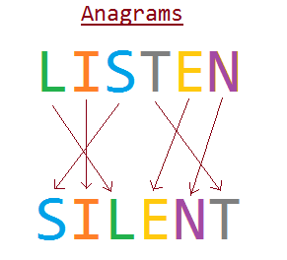
Inputs:
silent
listen
Output: anagram

Inputs:
kazak
kabak
Output: not anagram

11- Write a program that shifts each word in the string to the left by 2.

Example:
Input: Algorithm course
Output: gorithmAl urseco

